***EXTRACTING ENERGY FROM BLACK HOLES***

by Rodney Bartlett 1

1 Unaffiliated with Institution – Lives in Australia, Member of ResearchGate and ORCID, Certificates in Astrophysics from ANU (Australian National University), Certificates in Robotics from QUT (Queensland University of Technology, Australia)

**INTRODUCTION**

A dictionary definition of "challenge" is "something that is difficult or impossible". According to this, extracting energy from black holes both is and isn't a challenge. It isn't because we're already halfway to that goal for three main reasons - 1) the theories of Albert Einstein regarding gravitational waves, 2) an electrical engineering experiment reported on in 2009 by the USA's Yale University, and 3) existing terrestrial gravitational-wave detectors like LIGO and VIRGO, as well as planned space-based detectors like LISA. Extracting energy from black holes is a challenge since it requires humans to think differently about what's feasible in space (to be precise, space-time) exploration - and possibly, to think differently about what a black hole is. I'd be very surprised if these changes to people's thought patterns can be accomplished within one generation.

**2009 electrical-engineering experiment**

A 2009 electrical-engineering experiment at America's Yale University, together with the ideas of Albert Einstein, tells us how we could travel to other stars and galaxies. An electrical engineering team at Yale demonstrated that, on silicon-chip and transistor scales, light can attract and repel itself like electric charges or magnets. (Li 2009: “Tunable bipolar optical interactions between guided lightwaves” by Mo Li, W. H. P. Pernice & H. X. Tang, Nature Photonics 3, 464 – 468) This is the Optical Bonding Force. For 30 years until his death in 1955, Einstein worked on his Unified Field Theory with the aim of uniting electromagnetism (light is one form of this) and gravitation. Achievement of this means the quantum components (gravitons) of gravity/spacetime-warps between spaceships and stars could mimic the Optical Force and be attracted together, thereby eliminating distance (this, possibly acting in partnership with repulsion, could produce a wormhole, or shortcut between folds in space and time). If the gravitons are superposed and entangled, distances between both points in space and points in time are totally eliminated.

As stated in a robotics lesson, "the time variable t varies from 0 to 1, that is, 0 ≤ t ≤ 1". (MATLAB (2019): "MATLAB: Interpolation of a scalar" by Peter Corke and the Queensland University of Technology: https://www.futurelearn.com/courses/making-robots-move/6/steps/570340) Therefore, this article’s logic states that 0 may be equal to 1 (division by 1 is accepted, so why isn't division by 0?) Since time is permanently united with space in physics, 0=1 in space-time too. This is consistent with a proposed future theory of physics called Quantum Gravity; where Quantum Mechanics is united with General Relativity, Einstein's theory of gravity. A possible path to attainment of quantum gravity is realizing that all objects and events on Earth and in space-time are just one thing - like 0 equalling 1, and like the objects in a computer image seeming to be a lot of separate objects but really just being one thing (strings of the binary digits 1 and 0, which can represent electrical pulses being "on" or "off"). A spacecraft sitting on its launchpad can be assigned t=0, and its destination t=1. Since 0=1, reaching the destination takes the same time as reaching the launchpad from the craft’s position on the launchpad (travel is instant). Robot motion can also be instant and not require interpolation, which is making the end of a robot arm move smoothly from A to B through a series of intermediate points. Of course, this is nonsense if viewed from CLASSICAL mechanics. We need a mindset immersed in QUANTUM mechanics which has been extended to macroscopic entanglement.

**GRAVITATIONAL-ELECTROMAGNETIC UNIFICATION**

What's a method that suggests the unifying of gravitation and electromagnetism? Electronics' binary digits can be used to draw a two-dimensional computer image of a Mobius strip. Two united Mobius strips create a three-dimensional figure-8 Klein bottle, (Polthier 2003: "Imaging maths - Inside the Klein bottle" by Konrad Polthier, http://plus.maths.org/content/os), that acts as a building block of space, time, forces’ bosons and matter’s fermions. This creates a supersymmetry (linkage) between fermions and bosons. A recent paper (Afshordi (2017): “From Planck Data to Planck Era: Observational Tests of Holographic Cosmology” by Niayesh Afshordi, Claudio Corianò, Luigi Delle Rose, Elizabeth Gould, and Kostas Skenderis, Phys. Rev. Lett. 118, 041301, https://journals.aps.org/prl/abstract/10.1103/PhysRevLett.118.04130) says that in a holographic universe, all of the information in the universe is contained in two-dimensional packages trillions of times smaller than an atom. Therefore, trillions of Mobius strips could form a photon and trillions of more complex figure-8 Klein bottles could form a more complex graviton (suggesting union of electromagnetism and gravitation).

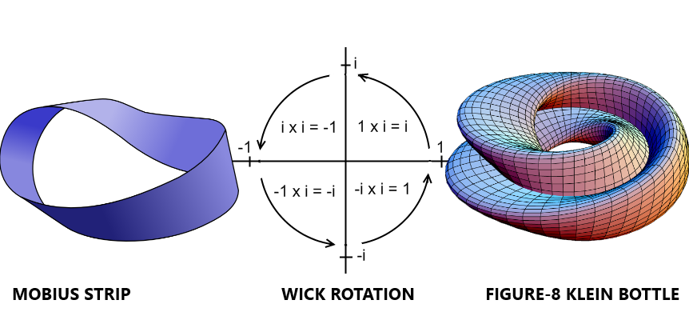

The physicist and science historian Abraham Pais wrote that “In 1924 the scientist Wolfgang Pauli was the first to propose a doubling of electron states due to a two-valued non-classical "hidden rotation", (Pais 1991: “Niels Bohr's Times” by Abraham Pais, Oxford: Clarendon Press, p. 201). Extending the ideas of “doubling”, “two-valued” and “hidden rotation” to the Mobius strip being a basic, fundamental unit of reality; it can be seen that Pauli’s proposal has an analogy to this article. The doubled Mobius strips (doubled to form a figure-8 Klein bottle) could be produced by the two-valued binary-digit system used in electronics. The bottles possess a hidden rotation, now identified as adaptive Wick rotation, which gives a fourth dimension to space-time. Using the photoelectric effect to explain that the so-called imaginary numbers and imaginary time of the Complex Number Plane's y-axis can be real, this Wick rotation - after a short section on imaginary computers - is shown to be consistent with Special Relativity’s slowing of time (a.k.a. time dilation):

**Imaginary Computers - GOING BEYOND QUANTUM COMPUTERS WITH "IMAGINARY" TIME**

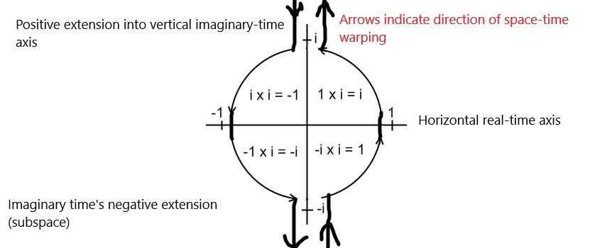

**SPACE-TIME WARPING IN IMAGINARY COMPUTER**

Our present approach to developing computers has gone about as far it can. The problems of chips generating too much heat - and of quantum uncertainties making transistors hopelessly unreliable at the scale of atoms - demand a new approach. I'm proposing that the successor to today's silicon technology (and tomorrow's quantum computers) lies in new concepts of time. An "imaginary" computer using the Complex Number Plane's vertical axis of imaginary time can perform calculations at the familiar rate of time's passing while the horizontal axis of "real" time sees absolutely no elapsed time (the possibility of no time passing in the normal sense is hinted at by Special Relativity's time dilation or slowing of time).

For a hundred and ten years, science has accepted the concept of space-time which was formulated by Russian-German mathematician Hermann Minkowski and unites one time dimension with three space dimensions. Today, so-called imaginary numbers (such as i, which equals √-1) describe so-called imaginary time. Imaginary time is a concept derived from special relativity and quantum mechanics. Geometrically, imaginary numbers are found on the vertical axis of the Complex Number Plane, allowing them to be presented perpendicular to the real axis of space-time as we know it. One way of viewing imaginary numbers is to consider a standard number line, positively increasing in magnitude to the right, and negatively increasing in magnitude to the left. At 0 on this x-axis (the so-called real axis), a y-axis (the so-called imaginary axis) can be drawn with "positive" direction going up - "positive" imaginary numbers then increase in magnitude upwards, and "negative" imaginary numbers increase in magnitude downwards.

The ultraviolet catastrophe, also called the Rayleigh–Jeans catastrophe, is a failure of classical physics to predict observed phenomena: it can be shown that a blackbody - a hypothetical perfect absorber and radiator of energy - would release an infinite amount of energy, contradicting the principles of conservation of energy and indicating that a new model for the behaviour of blackbodies was needed. At the start of the 20th century, physicist Max Planck derived the correct solution by making some strange (for the time) assumptions. In particular, Planck assumed that electromagnetic radiation can only be emitted or absorbed in discrete packets, called quanta. Albert Einstein postulated that Planck's quanta were real physical particles (what we now call photons), not just a mathematical fiction. From there, Einstein developed his explanation of the photoelectric effect (when quanta or photons of light shine on certain metals, electrons are released and can form an electric current). So it appears entirely possible that another supposed mathematical trickery (the imaginary y-axis) will find practical application in the future.

**TIME DILATION, DARK MATTER, AND DARK ENERGY**

The electromagnetic and gravitational waves composing space-time rotate in a cycle. The waves rotate through the vertical y-axis* that is home to so-called Dark Matter and the Dark Energy composing it, and back to the horizontal x-axis' space-time. (As NASA’s measurements reveal in the next paragraph, the composition of dark matter by dark energy isn’t as simple as energy=mass in all cases i.e. it isn’t always similar to ordinary energy composing ordinary matter via E=mc^2.) Since quantum mechanics says particles can be in two or more places at once, the photons and gravitons which make up the waves in space-time can be on the x- and y-axes simultaneously and thus interfere with themselves, causing time to slow down significantly near the speed of light in a vacuum or under intense gravity.

*The dark matter/dark energy (DM/DE) residing at or near the Complex Number Plane’s y axis remains in space-time's curves (in gravity) so it gravitationally affects space-time on the x axis. But this exotic mass-energy lies perpendicular (or almost perpendicular) to each dimension of our instruments, and thus electromagnetically undetectable (at least at present). 5.5 rotations, each of ~ 65.45 degrees, means there would be 5 1/2 times as much dark matter as ordinary matter (or, to use NASA's number (NASA (2019): "NASA SCIENCE - Dark Energy, Dark Matter", https://science.nasa.gov/astrophysics/focus-areas/what-is-dark-energy), about 27% of the universe would be DM). Constant rotation keeps the x- and y-axes interactive but doesn't make more ordinary matter since the x-axis is restricted to E=mc^2 (the amount of available energy limits the production of matter). Mass-energy equivalence may not be DE=DMc^2 in every "dark" dimension. In some, there might be more "dark" energy available. It'd be possible for the universe to contain more than 5.5 times as much energy as our dimension. DE could be roughly 68% of the content of the cosmos.

**BLACK HOLES ACCORDING TO VECTOR-TENSOR-SCALAR (VTS) GEOMETRY**

**SUBSECTION 1 - GRAVITY, THE HIGGS AND JETS**

“Dust grains assemble by chemical bonding. Once they are sand or gravel sized, how they continue to stick is a mystery. Metre-sized rocks should spiral into the star rapidly due to disc drag (the gas orbits a little slower than the rocks as a pressure gradient partially supports it). Once rocks somehow get past these barriers, they collide with each other in a chaotic and random way assembling the planets.” (Australian National University (2012-2019): “Greatest Unsolved Mysteries of the Universe” (presented on edX by Prof. Brian Schmidt and Dr. Paul Francis), ANUx - ANU-ASTRO1x: Lesson 8 (Solar System Formation), https://courses.edx.org/courses/course-v1:ANUx+ANU-ASTRO1x+2T2016/course/)

The following method of building planets is preferred to collisions between rocks and dust in the disc because most planetary systems seem to outweigh the protoplanetary discs in which they formed, leaving astronomers to re-evaluate planet-formation theories. (Astronomy (2019): ”AstroNews”, February, p. 17)

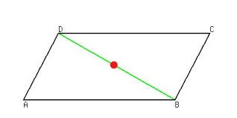

**VTS (VECTOR-TENSOR-SCALAR) GEOMETRY** - Interaction of Gravitation and Electromagnetism Produces a Momentum in Gravitons and Photons (and a Pressure Which is Known as Mass). VTS Geometry inspired by (Einstein (1919): “Spielen Gravitationfelder in Aufbau der Elementarteilchen eine Wesentliche Rolle?” [Do gravitational fields play an essential role in the structure of elementary particles?] by Albert Einstein, Sitzungsberichte der Preussischen Akademie der Wissenschaften, [Math. Phys.], 349-356, Berlin)

A vector is a quantity which possesses both magnitude and direction. Two such quantities acting on a point may be represented by two adjoining sides of a parallelogram, so that their resultant is represented in magnitude and direction by the diagonal of the parallelogram (AD and CD, for example, can symbolize the electromagnetic and gravitational vectors … while the resultant green diagonal of DB substitutes for the interaction of those two forces). A scalar variable is representable by a position on a line, having only magnitude e.g. the red dot on the diagonal, symbolic of the Higgs boson. A tensor is a set of functions which, when changing from one set of coordinates to another, are transformed in a precisely defined manner (e.g. changing from the coordinates of AD and CD to those of the green diagonal, or of the red dot, is a transformation performed in a particular way). Adapted from Macquarie (2001): "Vector", "Tensor" and "Scalar", The Macquarie Concise Dictionary, edited by A. Delbridge and J. R. L. Bernard

Two sides thus illustrate the graviton's spin 2 and the photon's spin 1. The resultant diagonal represents the interaction of the sides/vectors (1÷2 = the spin ½ of every matter particle). Tensor calculus changes the coordinates of the sides and diagonal into the coordinates of a single (scalar) point on the diagonal. This scalar point is associated with particles of spin 0. (Klauber (2018): “Scalars: Spin 0 Fields” by Robert D. Klauber, http://www.quantumfieldtheory.info/Chap03_pgs_40_48.pdf#:~:text=Particles%20with%20zero%20spin%2C%20such%20as%20%EF%81%B0-mesons%20%28pions%29,and%20named%20after%2C%20Oscar%20Klein%20and%20Walter%20Gordon.) If the mass produced during the photon-graviton interaction (the energy and momentum of photons and presently hypothetical gravitons produces a pressure we call mass*) happens to be 125 GeV/c^2, its union with spin 0 produces the Higgs boson. 125 GeV/c2 united with spin 0 means the central scalar point of the Higgs boson is related to the vector of the graviton’s spin 2, and the Higgs field is therefore united with the supposedly unrelated gravitational field (together with the latter’s constant interaction with the electromagnetic field).

*Material from a star could fall onto a neutron star, heating it up and causing it to emit radiation. Then the energy and momentum of the photons and presently hypothetical gravitons would be the interaction of electromagnetism (the charged particles and strong magnetism) with the neutron star's powerful gravity. This results in wave-particle duality. The heating could produce gravitational and electromagnetic radiation which would produce the mass and quantum spin of subatomic particles - instead of only radiation being emitted, jets of matter would be emitted too (normally, the matter would be emitted as beams or jets from the neutron star’s magnetic poles).

**SUBSECTION 2 - BOSONS AND PLANET/BLACK-HOLE FORMATION**

It must be remembered that referring to space alone is incomplete. Living in space-time, it’s necessary to add some sentences about the time factor. The photon must interact with the graviton to produce the mass of the weak nuclear force’s W and Z bosons. To produce their quantum spin, the photon’s spin 1 needs to react with the graviton’s spin 2. That is, the photon’s turning through one complete revolution needs to be combined with the graviton’s being turned through two half- revolutions*. Incorporating the time factor as a reversal of time (Richard Feynman, 20th-century winner of the Nobel Prize in Physics, used reversal-of-time to explain antimatter) in the middle of the interaction: a gravitonic half revolution is subtracted from the photonic full revolution then the graviton’s time-reversal adds a half revolution (1-½+½ = the spin 1 of W and Z bosons). The strong nuclear force’s gluon’s quantum spin of 1 could arise in the same way as the spin 1 of weak-force bosons. Every reaction in this section except one may be explicable purely by the retarded** portions of waves interacting. The masslessness of gluons might be produced by retarded and advanced waves cancelling. They neutralize each other, producing a mass of zero and relating gluons to the Higgs boson whose zero quantity is its quantum spin.

*Professor Stephen Hawking writes, (Hawking (1988): “A Brief History of Time” by Stephen Hawking, Bantam Press, pp.66-67) -

"What the spin of a particle really tells us is what the particle looks like from different directions."

Spin 1 is like an arrow-tip pointing, say, up. A photon has to be turned round a full revolution of 360 degrees to look the same.

Spin 2 is like an arrow with 2 tips - 1 pointing up, 1 down. A graviton has to be turned half a revolution (180 degrees) to look the same.

Spin 0 is like a ball of arrows having no spaces. A Higgs boson looks like a dot: the same from every direction.

Spin ½ is logically like a Mobius strip, though Hawking doesn’t specifically say so. This is because a particle of matter has to be turned through two complete revolutions to look the same, and you must travel around a Mobius strip twice to reach the starting point.

**"When we solve (19th-century Scottish physicist James Clerk) Maxwell's equations for light, we find not one but two solutions: a 'retarded' wave, which represents the standard motion of light from one point to another; but also an 'advanced' wave, where the light beam goes backward in time. Engineers have simply dismissed the advanced wave as a mathematical curiosity since the retarded waves so accurately predicted the behavior of radio, microwaves, TV, radar, and X-rays. But for physicists, the advanced wave has been a nagging problem for the past century." (Kaku (2009): "Physics of the Impossible" by Michio Kaku, Penguin Books, p. 276)

The interacting gravity and electromagnetism produce mass e.g. they can form a Higgs boson or the strong/weak nuclear forces’ bosons as well as matter. On a cosmic level - if gravitational and electromagnetic waves focus on a protoplanetary disc surrounding a newborn star, the quantum spin of the particles of matter in the disc (1 / 2) could imprint itself on the waves’ interaction and build up a planet layer by layer from vector-tensor-scalar geometry’s 1÷2 interaction. If the waves focus on a region of space where there’s no matter, the opposite interaction occurs and the graviton’s spin 2 is divided by the photon’s spin 1 to produce 2÷1. The mass produced has the spin inherent in each of the gravitons composing spacetime - and could be an alternative, or complementary, method to supernovas for producing the gravitational waves making up black holes.

**ENERGIES KNOWN AND UNKNOWN**

Finally, imagine that a future space-based gravitational-wave detector such as LISA is transported via a sophisticated development of Yale University's electrical-engineering experiment in 50 years. Being instantly transported 1,000 or 25,000 light years - or wherever or whenever it needs to go - the waves it encounters would be almost immeasurably more powerful than those detected thousands or billions of light years away on Earth. Vector-Tensor-Scalar Geometry hints that electromagnetic as well as gravitational waves may be detected since both types of waves may be involved with production of black holes' mass. All waves could then be put to work and give us many forms of energy - electrical, magnetic, radio, optical, X-ray, gravitational energy of various amplitudes, frequencies and phases.